Team Members: Timothy Small, William Kingsley, Allen Simpson

CSCI 440 Database Systems

24 September 2019

Project Proposal

We are looking at representing an online grocery store. We are representing the following entities: Customers, Products, Distributers, Cards (Weak), Addresses (Weak), Shipping Companies, and Items. The ER Diagram for the project is Figure 1 on the next page.

We display customers, cards, addresses, and products as having a large number of attributes, where the remaining entities has relatively few (usually just an ID and name).

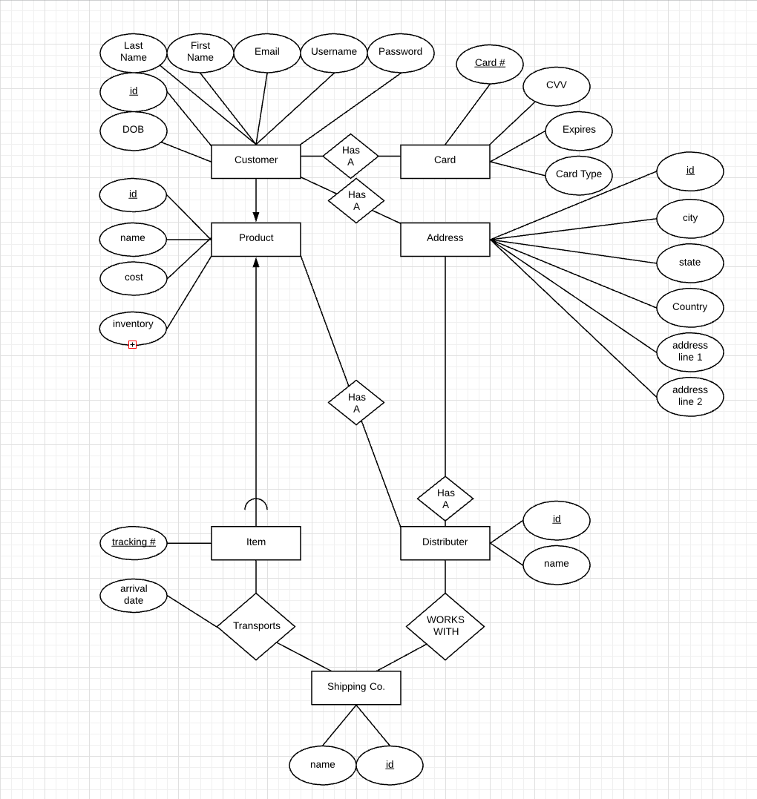

**Figure 1: ER Diagram for project**